BNMQG APRIL 2018 BLOCK LOTTO
COLOR BLOCKING
Block should measure 12.5” unfinished

FABRICS: fat quarters are plenty or use your scraps from other projects. White on white—try using the wrong side. Grey on grey print or may have a bit of white &/or black in it with a grey background. Black print with a bit of grey &/or white in it. Bright jewel tone solids - you most likely have scraps of solids. Remember don’t use darks—they get lost in the black.

CUTTING:

5” x 9.5” rectangles - 1 of white, 1 of black
3.5” squares - 1 of white, 1 of black
3.5” x 6.5” rectangle - 1 of grey
3.5” x 5” rectangles – 1 each of 2 different bright solids

LAY OUT: arrange pieces as shown in photo.

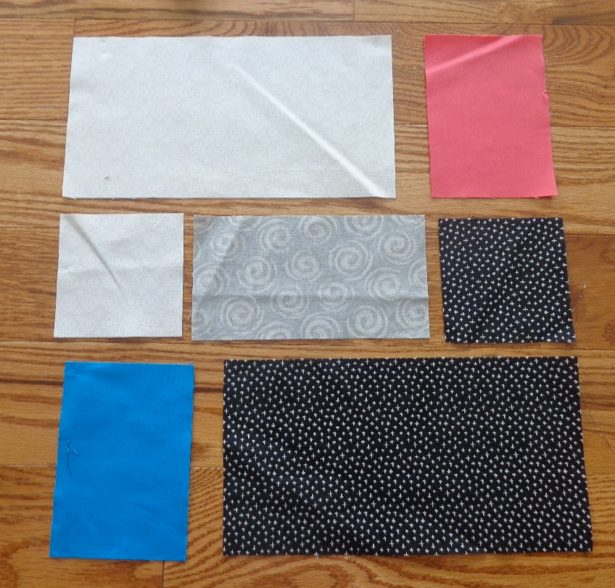

SEWING: sew each row together with ¼” seam allowance. Press seams open. Pin rows 1 & 2 together being very careful to match seams. Sew and press seam open. Sew rows 2 & 3 together matching seams. Sew and press seam open.

Press entire block. It should measure 12.5” square. Put your name on the back of the block. Bring it to the May 22nd meeting.
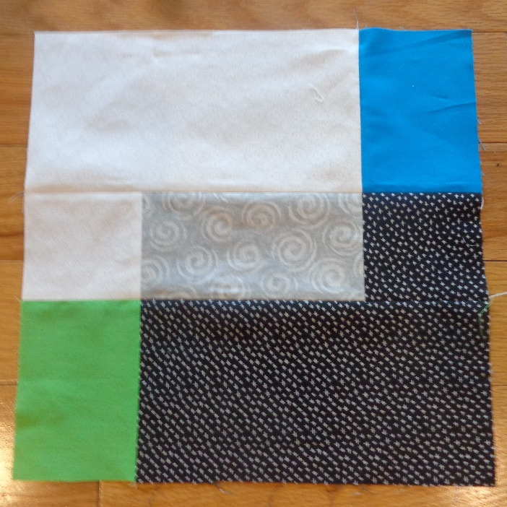

This was so easy, make a few more ! If you have any questions, e-mail me. sosew-7828@sbcglobal.net

viv

